Project Design Phase
Problem – Solution Fit Template
Date | 10 July 2026
Team ID | [Your Team ID]
Project Name | House Rent — Broker-Mediated Real Estate Platform
Maximum Marks | 2 Marks
Problem – Solution Fit:
The canvas below maps our customer segments, their existing behaviour, and the emotional pain points against the specific parts of House Rent that address them — principally the admin/broker approval gate and the dual-role (Owner + Renter) account model.
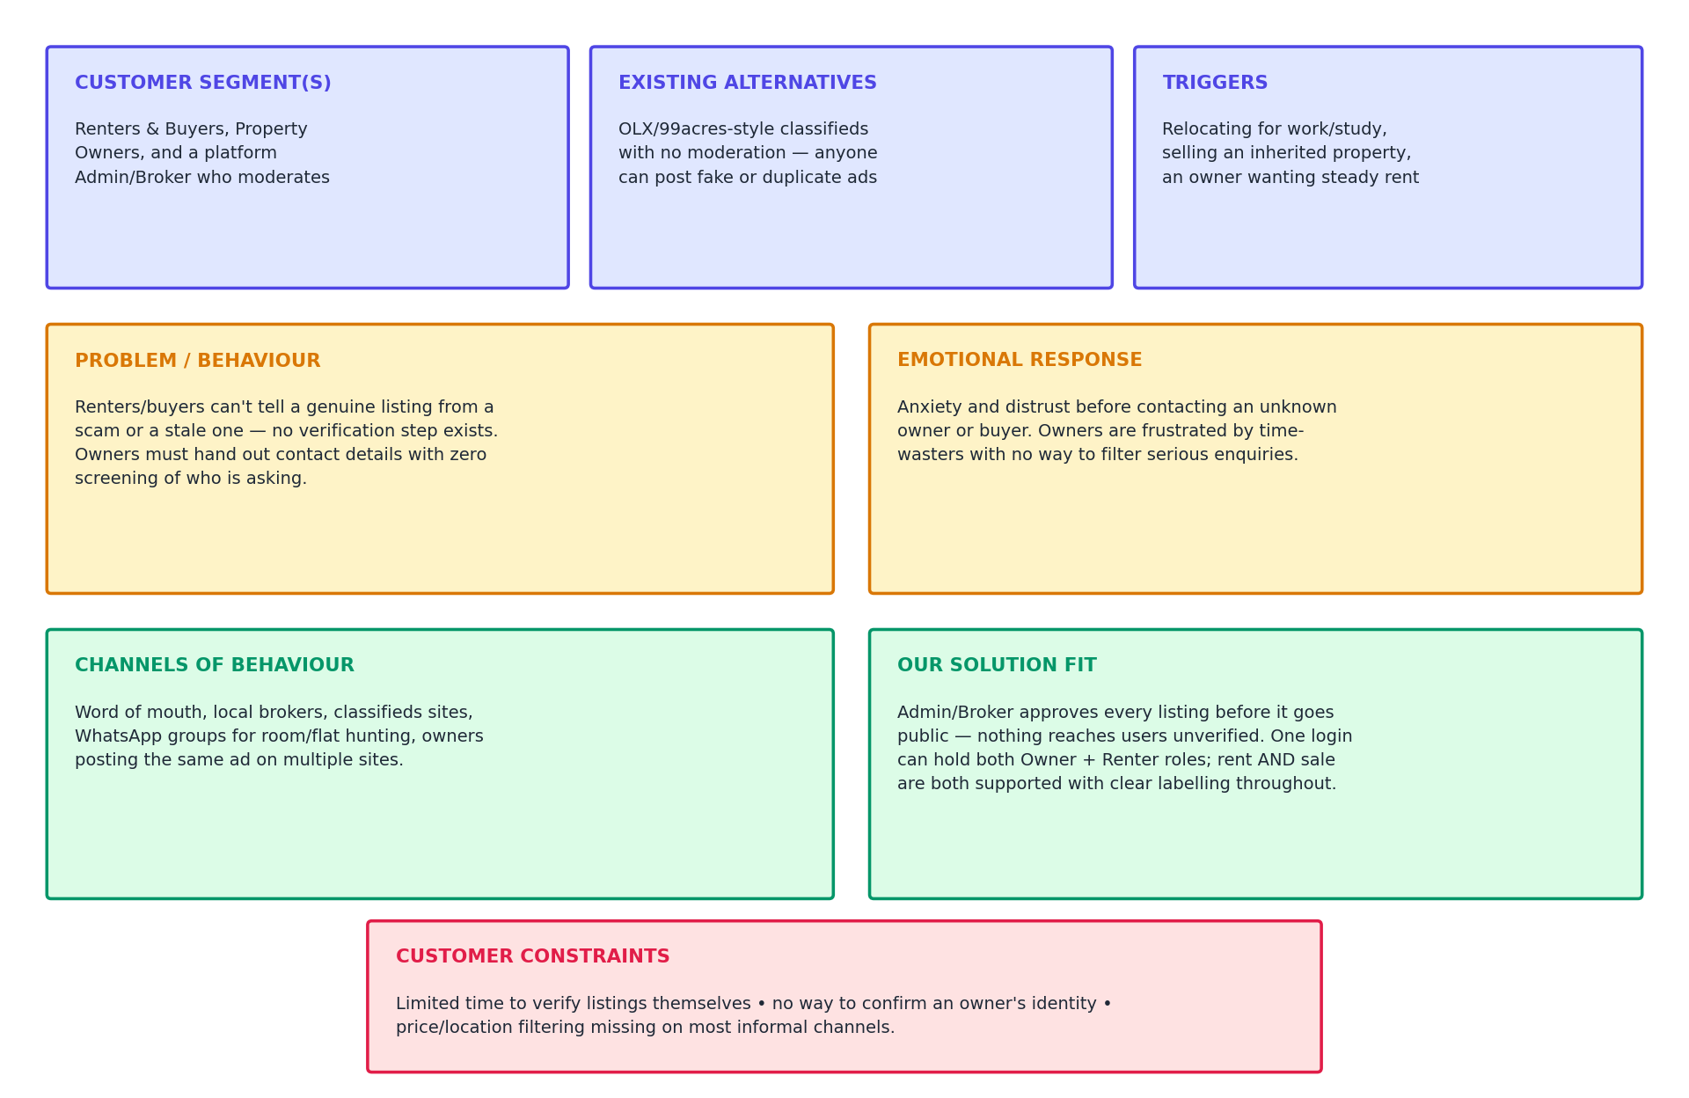
Figure: Problem – Solution Fit Canvas for House Rent
How This Shaped the Solution:
- Because trust was the dominant emotional response, we made approval mandatory server-side (a property literally cannot be booked while status is “pending” or “rejected”), not just hidden in the UI
- Because owners and renters are often the same people at different times, one login can hold both roles instead of forcing two separate accounts
- Because search efficiency was a recurring behaviour, filters (location, price range, property type, rent/sale) were built into the core browse experience from the start, not added later

